# File permissions in Linux

## Project description

Check permissions for all files in the directory, including any hidden files, to make sure that permissions are given to the users.

## Check file and directory details

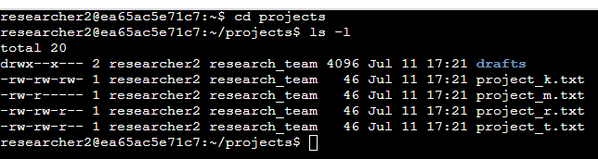

**Cd projects**

(to put me in the directory i want to check the permissions)

**Ls -l**

(to display all permissions to files and directories)

## Describe the permissions string

Subdirectory **drafts** permissions

**User**: read, write, execute **Group**: execute **Other** : none

**File** permissions for p**roject_k.txt**

**User**: read, write **Group**: read, write **Other** : read, write

**File** permissions for p**roject_m.txt**

**User**: read, write **Group**: read **Other** : none

**File** permissions for p**roject_r.txt**

**User**: read, write **Group**: read, write **Other** : read

**File** permissions for p**roject_t.txt**

**User**: read, write **Group**: read, write **Other** : read

## Change file permissions

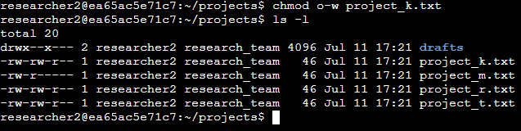

**Chmod o-w project_k.txt**

(to change the permissions for other not to able to write to project_k.txt)

**Ls -l**

(to display all changes made for permissions to files and directories)

## Change file permissions on a hidden file

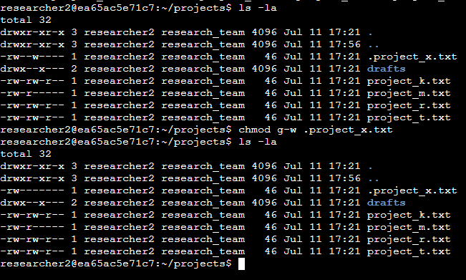

**Ls -la**

(displays permissions to files, directories, and hidden files)

**Chmod g-w .project_x.txt**

(to change the permissions for group not to able to write to .project_x.txt)

**Ls -la**

(to display all changes made for permissions to files and directories)

## Change directory permissions

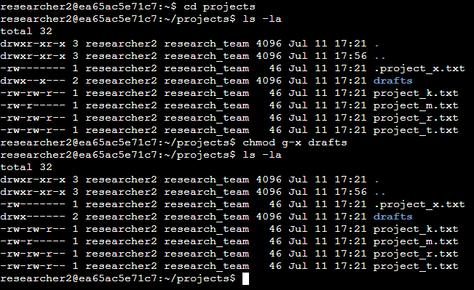

**Ls -la**

(displays permissions to files, directories, and hidden files)

**Chmod g-x drafts**

(to change the permissions for group not to able to execute to drafts)

**Ls -la**

(to display all changes made for permissions to files and directories)

## Summary

In this project, I demonstrated how to check and change permissions to files and directories. Described the commands I used and provided screenshots detailing my progress.